Appendix I

Databases in Electronic Commerce

Discussion Focus

Use some major websites to illustrate the use of electronic commerce. For example, show how you would buy an airline ticket, a computer, or a book. This chapter’s problem section is an excellent source for discussions about the use of the Web to buy goods and services and to make product/services/price comparisons. www.pricewatch/com and www.priceline.com are excellent ways to illustrate how you might become a more informed shopper.

Answers to Review Questions

- What does e-commerce mean and how did it evolve?

Electronic commerce (e-commerce) is the use of electronic computer-based technology to:
- Bring new products, services or ideas to market.
- Support and enhance business operations, including the sales of products and/or services over the web.

The Internet started in the early 1960’s as a military project to ensure the survival of computer communications in case of nuclear attack. However, the Internet soon became the prime vehicle for sharing academic research, thus making higher education institutions the Internet’s primary users. (Section I.2, “The Road to Electronic Commerce,” shows the evolution toward e-commerce.)
- During the early 1960’s, banks created a private telephone network to do electronic funds transfers (EFT). This service allowed two banks to exchange funds electronically in a fast, efficient, and secure manner.
- During the early 1970’s, banks also created services such as the Automated Teller Machine (ATM) to provide “after-hours” services to their customers. ATMs where initially installed by only a few banks nationwide and these banks permitted only a limited number of account transactions.
- During the late 1970’s and early 80’s, there was a boom in the use of Electronic Data Interchange (EDI). EDI enables two companies to exchange business documents over private phone networks. The use of EDI facilitated the coordination of business operations between business partners.
- The early 1980’s and all 1990’s brought us the personal computer, which triggered the Internet’s accelerated growth. The wide acceptance and use of the Internet led to the current dominance of the World Wide Web. The web made the transfer of information among multiple organizations as simple as a click away. The web also became a fertile ground for the exploration and exploitation of new Internet-based technologies for the enhancement of business processes within and between corporations.

- Identify and briefly explain five advantages and five disadvantages of e-commerce.

A summary of advantages of e-commerce is described in section I.3.1. We can briefly enumerate benefits such as:
- Comparison-shopping
- Reduced costs and increased competition
- Convenience for on-line shoppers
- 24 x 7 x 365 Operations
- Global Access
- Lower barriers of entry
- Increased Market (Customer) Knowledge

A summary of the disadvantages is presented in Section I.3.2 and they are summarized as follows:
- Hidden costs of operation
- Network unreliability
- Higher costs of staying on business
- Lack of security
- Loss of privacy
- Low service levels
- Legal issues (fraud, copyright problems)

- Define and contrast B2B and B2C e-commerce styles.

E-commerce styles can be classified as:
- Business to Business (B2B): electronic commerce between businesses.
- Business to Consumer (B2C): electronic commerce between businesses and consumers.
- Intra-Business: electronic commerce activities between employers and employees.

Business-to-Business (B2B) is a type of e-commerce in which a business sells products and/or services to other business. B2B refers to all types of electronic commerce transactions that take place between businesses. The seller is any company that sells a product or service, using electronic exchanges (such as over the Internet or using EDI). The buyer may be a not-for-profit company such as the Red Cross, a for-profit company such as Dell Computers, or a government organization such as a local municipality.

A business to consumer (B2C) web site sells products or services directly to consumers or end-users. In B2C e-commerce, the main focus is on using the Internet -- in particular, the Web -- as a marketing, sales, and post-sales support channel.

A complete discussion about e-commerce styles is presented in Section I.4.

- Describe and give an example of each of the two principal B2B forms.

B2B Integration. In this scenario, companies establish partnerships to reduce costs and time, to improve business opportunities, and to enhance competitiveness. For example, a company that manufactures computers might partner with its suppliers for hard disks, memory and other components. Such a partnership will help automate its purchasing system by integrating it with its suppliers’ ordering systems – which, in turn, will tie into their respective inventory systems. In this case, when a component in company “A” gets below the minimum, it will automatically generate an order to supplier “S”. Both systems would be integrated and would exchange business data, probably using XML. (See Section 13.8). Using the same technique, Company “A” may also integrate its distribution system with its distributors. Finally, the distributors may integrate their operations with those of their retailers, which in turn may integrate their activities with those of their customers. As a consequence of such integration, companies (sellers) learn to operate with other companies (buyers) and the integration of their operations makes it possible to achieve a level of efficiency that makes it difficult to switch to another provider.

B2B Marketplace. In this scenario, the objective is to provide a way in which businesses can easily search, compare, and purchase products and services from other businesses. The web-based system will basically work as an on-line broker to service both buyers and sellers. Given such an environment, many of the activities are focused on attracting new members -- either providers or buyers. The “broker” offers sellers a way to market their products and/or services to other businesses, while buyers are attracted by the fact that they can compare products from different buyers and get access to special deals that are offered only to the members. Given this B2B Marketplace scenario, the broker obtains revenue through membership and transaction fees. An example of a B2B web market place for the automotive industry is the http://www.covisint.com website.

- Describe e-commerce architecture: then briefly describe each one of its components.

The e-commerce architecture is described in detail in Section I.5, “E-commerce Architecture.” Start with the three layers: Basic Internet Services, Business Enabling Services, and E-commerce Business Services. Figure I.6, “E-commerce Architecture,” provides a good summary. The basic building blocks are provided in Table I.2, “Internet Building Blocks and Basic Services.” The business enabling services are summarized in Table I.3, “Business-Enabling Services.”

- What types of services are provided by the bottom layer of the e-commerce architecture?

The bottom layer if the e-commerce architecture, known as the Internet Basic Services, describes the basic building blocks and services that are provided by the Internet and the World Wide Web. The Internet provides the basic services that facilitate the transmission of data and information between computers.

- Name and explain the operation of the main building blocks of the Internet and its basic services.

The main Internet services are transport services -- such as TCP/IP, Routers and other protocols --, document formatting, storage, addressing, retrieval and presentation protocols such as the World Wide Web, web servers, web browsers, HTML, URL, HTTP, File Transfer Protocol, and other services such as e-mail, news groups and discussion groups. A complete description of the main Internet services is located in Chapter 13’s Table 13.1 and in Section 13.5.1.

- What does business-enabling do? What services layer does it provide? Give six examples of business enabling services.

The Internet Basic Services (IBS) only form a foundation on which to run a basic website. However, IBS does not provide the services required for even elementary business transactions. The Business Enabling Layer provides the additional services to better support business transactions.

Business transactions require accountability, reliability, authentication, trust, fidelity, and performance. These requirements are supported through hardware and software components that work together to provide the additional functionality not provided by the other layers. Table I.3 describes services that are used to enhance websites by providing their users the ability to perform searches, authenticate and secure business data, manage web site contents, and so on.

The list in Table I.3 is not exhaustive -- technological advances enable new services, which in turn are used to enable additional business services. The Business Enabling Services are search services, security, site monitoring and analysis, load balancing, personalization, web development, database integration, transaction management, messaging and support for multiple devices. The services provided by this layer are built on top of the Internet Basic services to provide the additional services that are required to support business transactions.

- What is the definition of security? Explain why security is so important for e-commerce transactions.

In an e-commerce context, security refers to all the activities that are associated with the protection of the data and other components against accidental or intentional (probably illegal) use by unauthorized users. Privacy deals with the rights of individuals and organizations to determine the “who, what, when, where and how” authorization to use his/her data.

Providing security is a major concern of e-commerce. Companies spend millions of dollars annually on hardware and software equipment to protect their own data (including personal customer data) and property against criminal activities. For e-commerce to be successful, it must ensure the security and privacy of all business transactions and the data associated with those transactions.

- Give an example of an e-commerce transaction scenario. What three things should security be concerned with in this e-commerce transaction?

E-commerce data must be secured from a transaction’s beginning to its conclusion. Note, for example the following transaction sequence:
- A customer buying products online from home, enters order and credit card information in a merchant’s web page.
- The information travels from the customer’s computer over the Internet to the merchant’s web server.
- The merchant’s web server receives the order and credit card data and stores these data in a database.
- The web server sends the order confirmation and shipping information back to the client.
- The seller uses a third-party shipping company to deliver the products to the customer.
- The seller uses a third party payment processing company to settle payment.
- The shipping company delivers the product to the customer.
- At the end of the month, the customer receives his/her credit card statement -- possibly electronically.
- The customer pays the credit card, either by writing and mailing a check or through the use of electronic funds transfer.

These transaction components are easily illustrated with the help of Figure I.8, “A Sample E-commerce Transaction.” Given the transaction scenario in Figure I.8, security (procedures and technology) deal with all activities required to:
- Warrantee the identity of the transaction’s participants by ensuring that both the buyer and the seller are who they say they are. In other words, it needs to exist a secure way to properly identify transaction participants and the authenticity of the messages.
- Protect the transaction data from unauthorized modifications while it travels on the Internet. Because it is not feasible to have private lines to connect every two computers, we use the Internet. Unlike private lines that directly connect the sender with the receiver, the Internet is formed by millions of interconnected networks. E-commerce data has to pass trough several different networks in order to travel from the client to the server; this increases the risks of data being stolen, modified or forged.
- Protect the resources (data and computers). This includes protecting the end-user and the business data stored on the web server and databases from unauthorized access. It also includes securing the web server against attacks from hackers wanting to break into the system with intentions of modifying or stealing data or of impairing normal operations by limiting the resource availability.

- You are hired as a resource security officer for an e-commerce company. Briefly discuss what technical issues you must address in your security plan.

The security plan should include issues such as physical security of the computing environment and protection of the data in the databases. On-line transaction security must also cover issues such as authentication, the use of digital certificates to ensure the identity of the parties involved in business transactions, and the use of public-key encryption with digital signatures to guarantee that the data traveling on the Internet cannot be tampered with or read by unauthorized parties.

The security plan should include issues such as resource security and transaction security. Transaction security includes encryption methods at the transport level, such as S-HTTP and SSL. Resource security deals with protecting the resources (hardware and software) that enable the conduct of e-commerce -- servers, routers, operating systems and applications – against threats posed by hackers, viruses, theft, and so on.

Problem Solutions

- Use the Internet at your university computer lab or home to research the scenarios described in Problems 1-10. Then work through the following problems:
- What web sites did you visit?
- Classify each site (B2B, B2C, and so on.)
- What information did you collect? Was the information useful? Why or why not?
- What decision(s) did you make based on the information you collected?

The format is provided in the answers to problems 2-9. Naturally, the web sites shown here change periodically, so use the examples as a general guide. Also, keep in mind that there are many sites beyond the sites we have shown in the answers to problems 2-9.

2. Research – and document -- the purchase of a new car. Based on your research, explain why you plan to buy this car.

A | B | C | D
Vehix.com  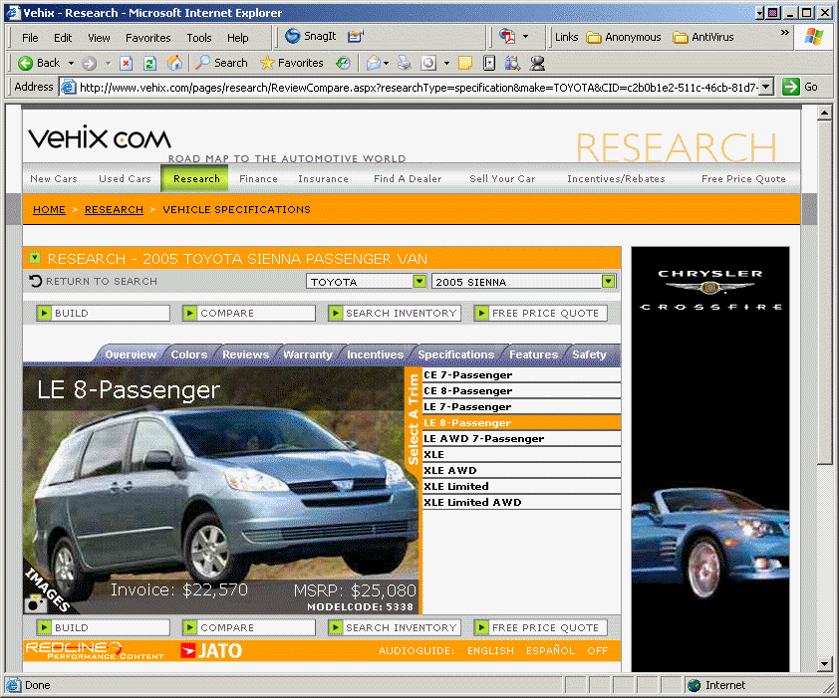 | B2C | Car models, features, comparisons, ratings, evaluations, dealer prices on new and used models.  Information was very useful. | Made an informed decision. Found the car most affordable, with best ratings and features. Capability of comparing car models and features.
CarMax.com  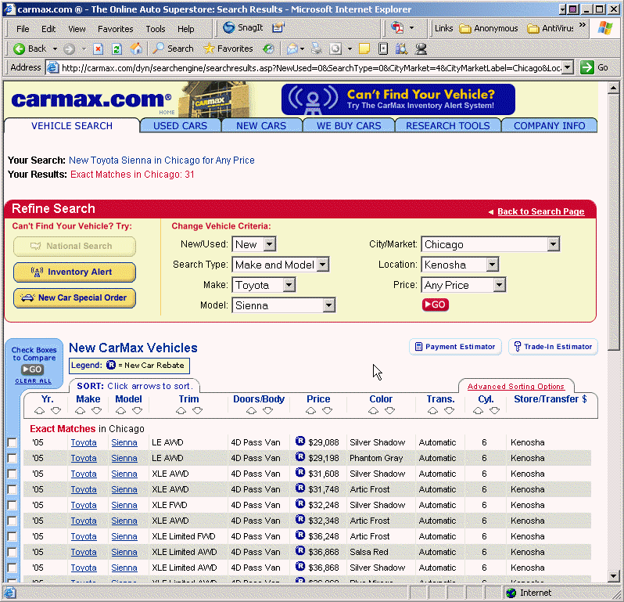 | B2C
AutobyTel.com  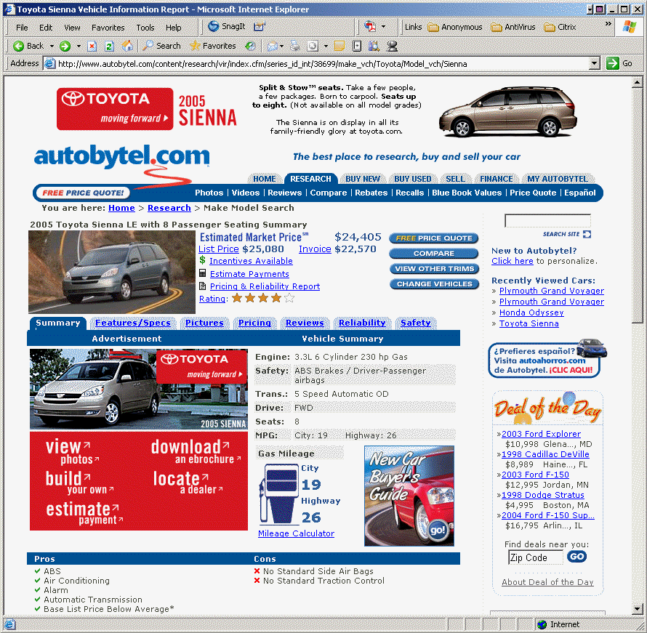 | B2C

3. Research – and document -- the purchase of a new house.

A | B | C | D
Century21.com  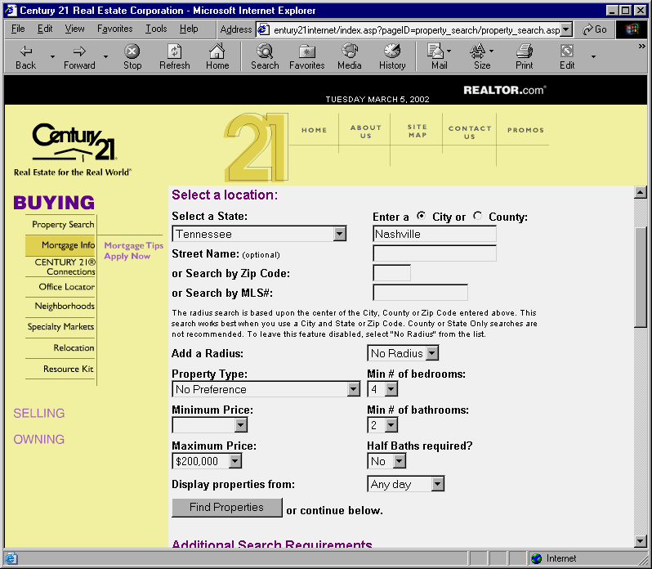 | C2B  B2C | Searched multiple homes based on my search criteria. Web sites provide information such as school systems, nearby attractions, city guides, comparable house prices, and financing options.  The sites also provided ways to place a home for sale. In addition, there were tips for buyers and sellers and price comparisons for new and older homes. Mortgage Calculators were available to help determine what the buyer can qualify for. | I was able to determine how much home I could afford, found a home within price range, locations and features desired.
RealEstate.com  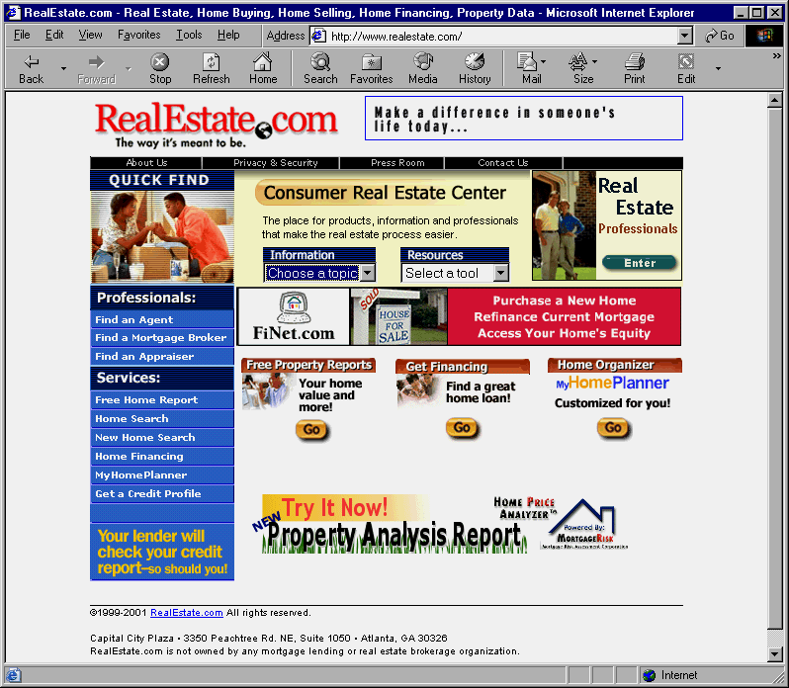 | B2C
ColdwellBanker.com  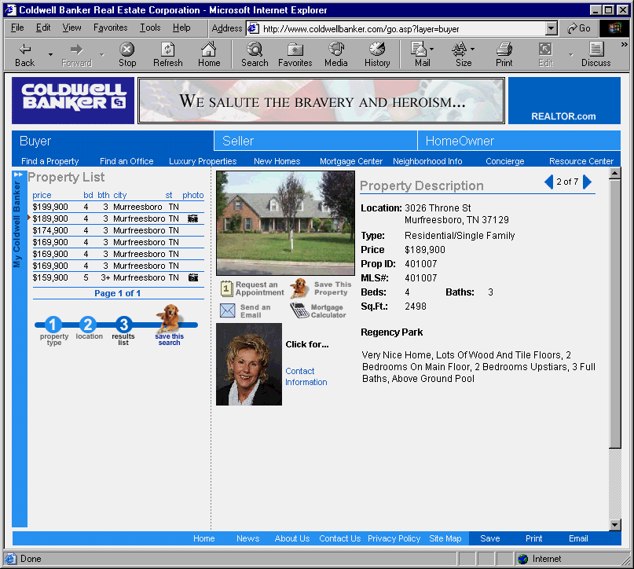 | C2B  B2C

4. You are in the market for a new job. Search the web for your ideal job. Document your job search and your job selection.

A | B | C | D
Monster.com  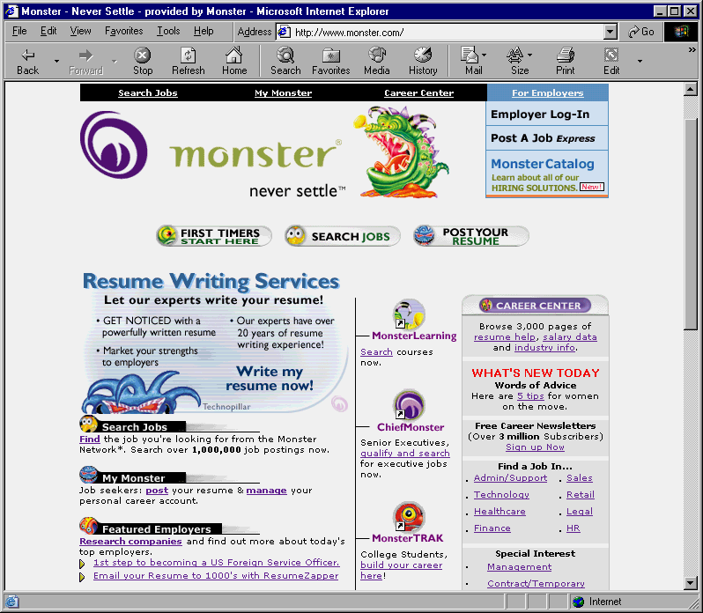 | C2B  B2C | Search job openings by location, industry, and salary range.  Research employers, salary comparison.  Option to post resume and obtain resume advice.  Resume writing service. Interview tips.  Salary calculators, relocation information and services. Moving information. | Was able to fine-tune a job search. Applied for jobs that matched my qualifications and experience.  Was able to research companies and to compare salaries in different geographic regions.
HotJobs.com  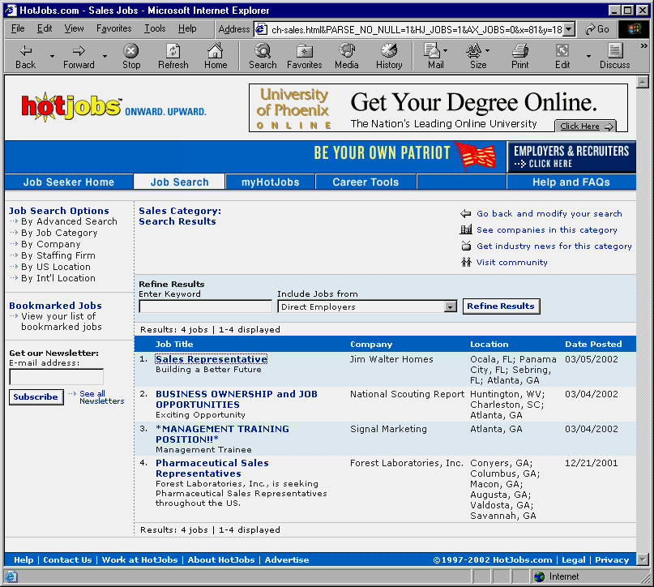 | C2B  B2B  B2C
Headhunter .net  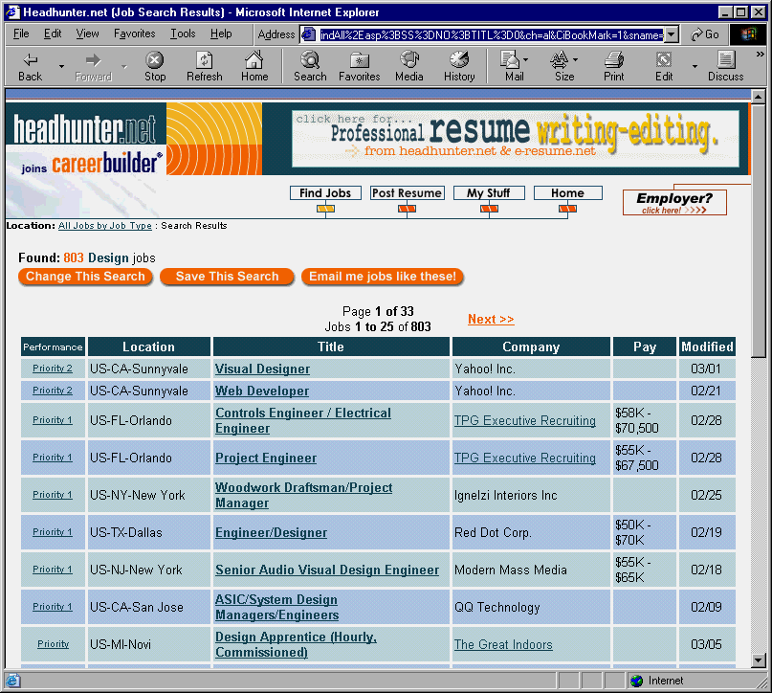 | C2B  B2B  B2C
5. You need to do your taxes. Download IRS form 1040 and look for online tax processing help, documenting your search.

A | B | C | D
IRS.gov  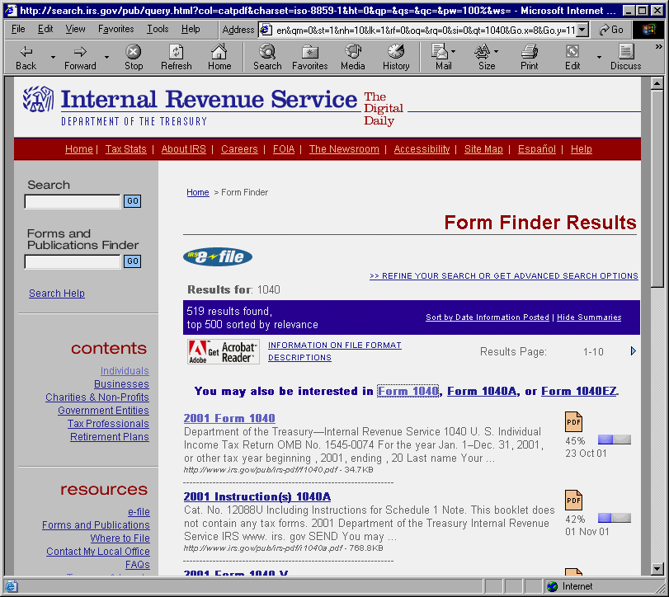 | G2C | Obtained information about latest tax laws, downloaded tax return forms. Learned how to file a tax return electronically.  Found information about IRS red flags for auditing.  Fond tax advice in many different areas, determined how much to save in multiple retirement instruments, etc. | Searched for tax advisors within my area.  Learned how retirement instruments can be used to save for retirement and to reduce the tax burden.  Used many different tax calculators to estimate how much I will pay in taxes.
Hrblock.com  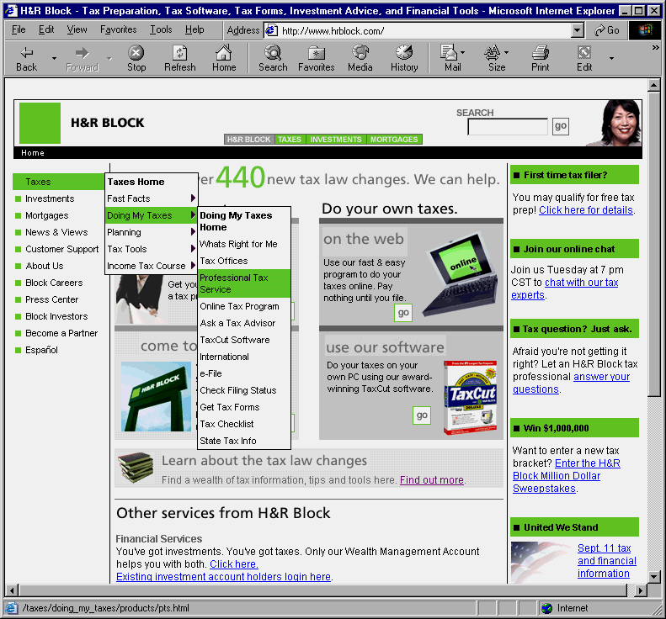 | B2C
CompleteTax.com  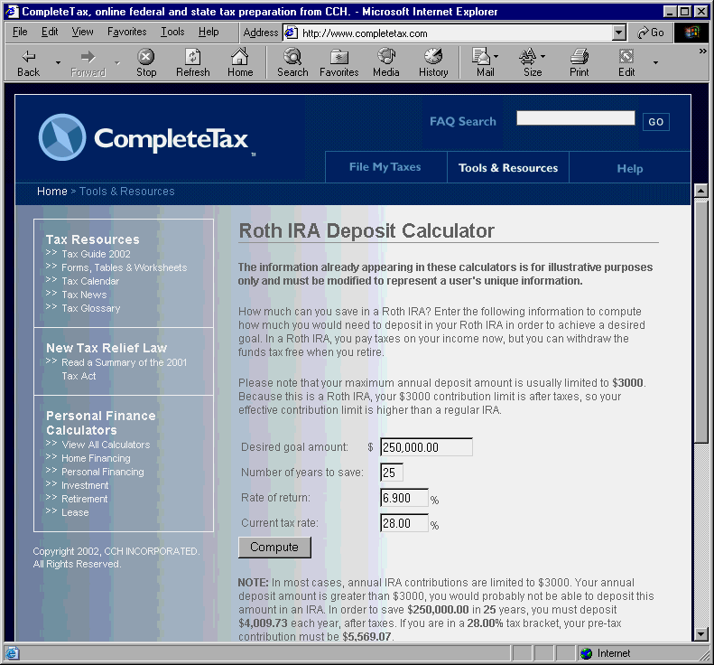 | B2C

6. Research the purchase of a 20-year level term life insurance policy and report your findings.

A | B | C | D
QuoteSmith.com  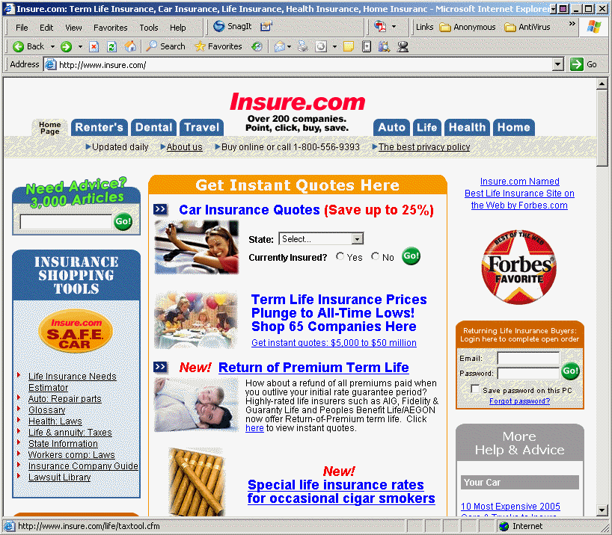 | B2B  B2C | Searched for policies by state, age, smoking status, and amount.  Obtained policy details, latest prices, and providers.  Compared insurance company premiums and ratings companies. | Could find best possible deals in no time at all.
Intellequote.com  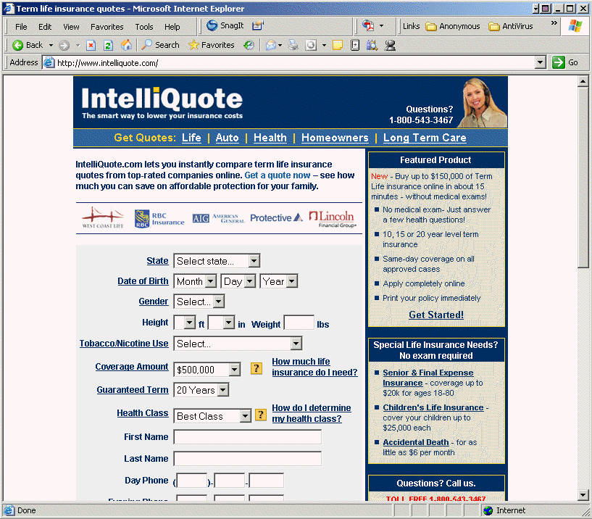 | B2B  B2C |  | Could find best possible deals in no time at all.
Conseco.com  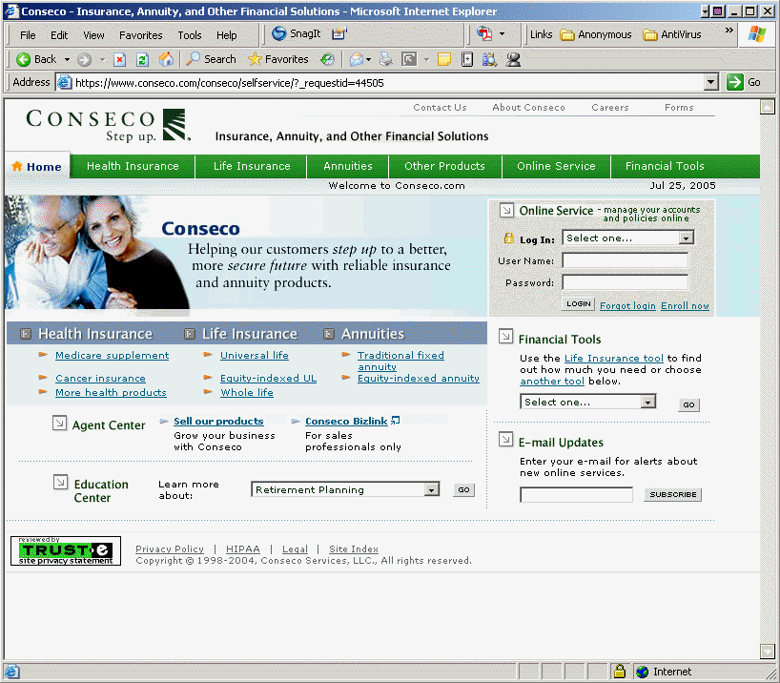 | B2C |  | Could find best possible deals in no time at all.

7. Research – and document -- the purchase of a new computer.

A | B | C | D
Dell.com  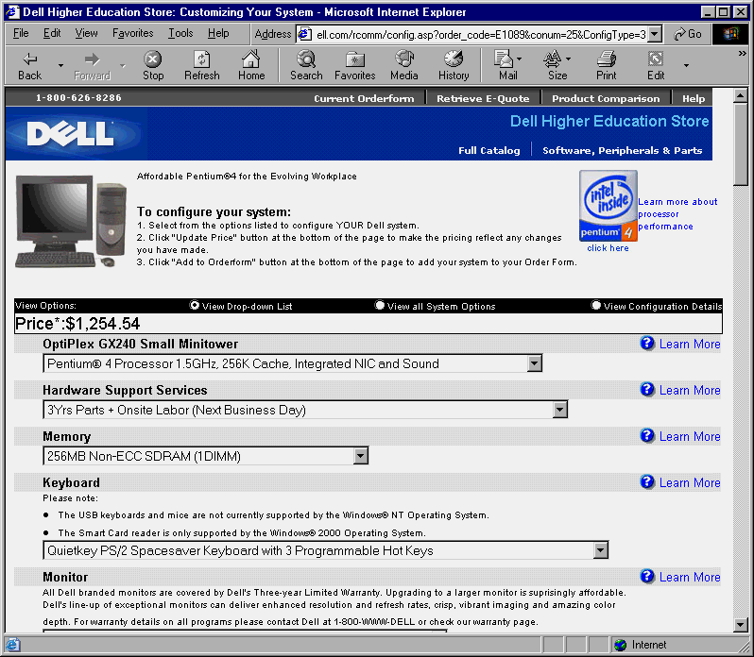 | B2C | Searched for computers, compared prices, options, and warranty information.  Could configure my computer according to my specifications.  Obtained leasing and credit term information.  Compare prices in new and refurbished computers. | I was able to find my computers at the right price, with the right features, and with the best warranty.
Pricewatch.com  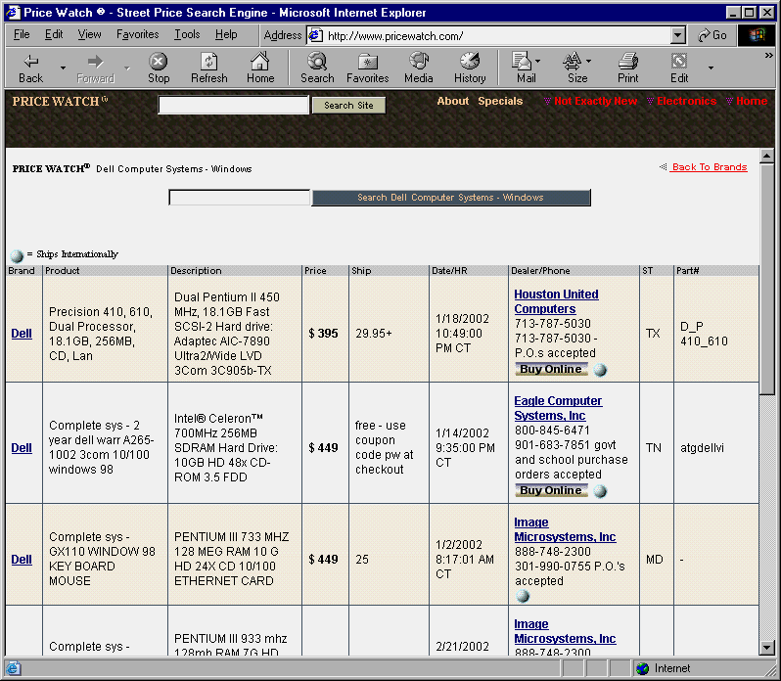 | B2C
Gateway.com  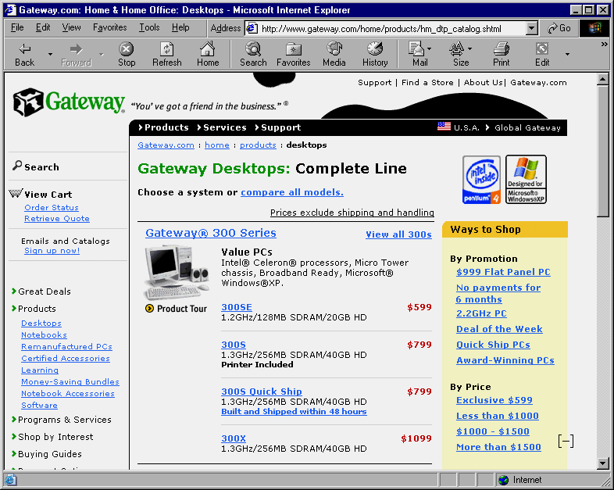 | B2C

8. Vacation time is almost here! Research—and document—the destination(s) and activities of next summer’s vacation.

A | B | C | D
Travelocity.com  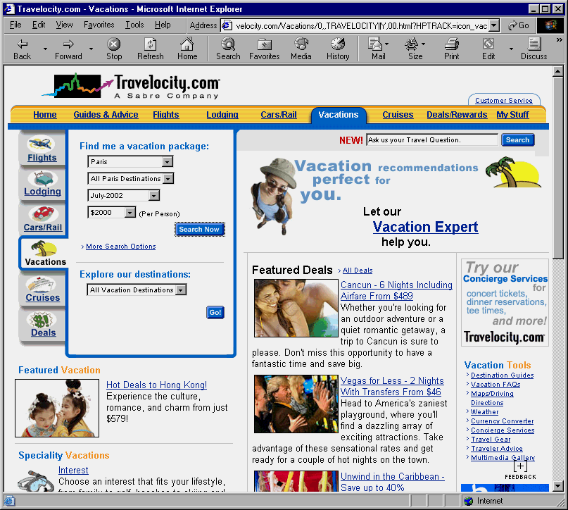 | B2C | Found information in vacation packages with all-inclusive features, such as air fare, hotel accommodations, and guided-tour details.  I was able to perform searches by destination, travel dates, tour operators, etc.  I could compare prices for tours and hotels. I was also able to find special deals and offers to various destinations.  I could do all the trip planning on-line and get additional information such as currency conversions, city guides, comments from past-users, weather information, etc. | I was able to search for (and find) multiple tour vacation packages that fit my criteria.  The information provided was also useful to completely plan the vacation and do all booking on-line.
TourDeals.com  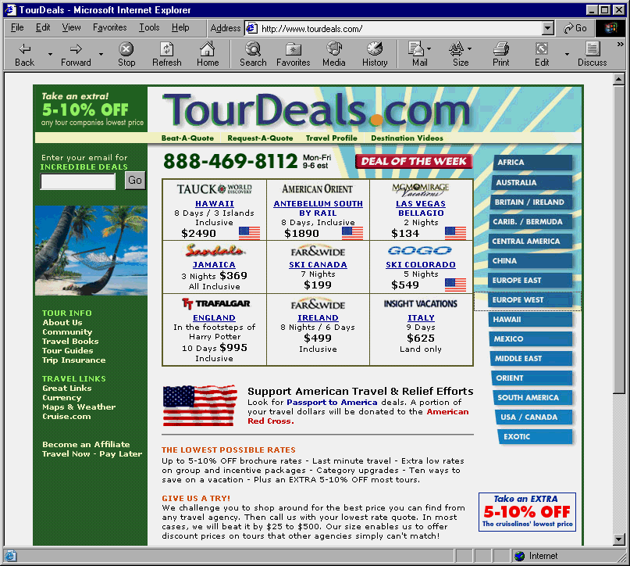 | B2C
Expedia.com  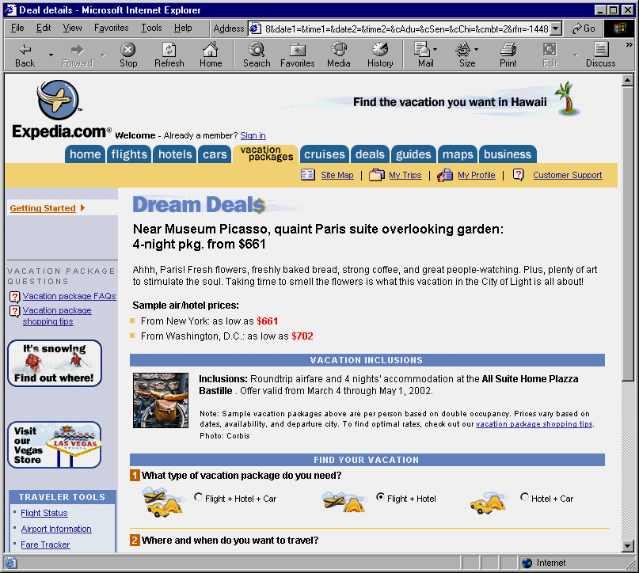 | B2C
9. You have some money to invest. Research – and document -- mutual funds information for investment purposes. Report your investment decision(s) based on the research you conduct.

A | B | C | D
Vanguard.com  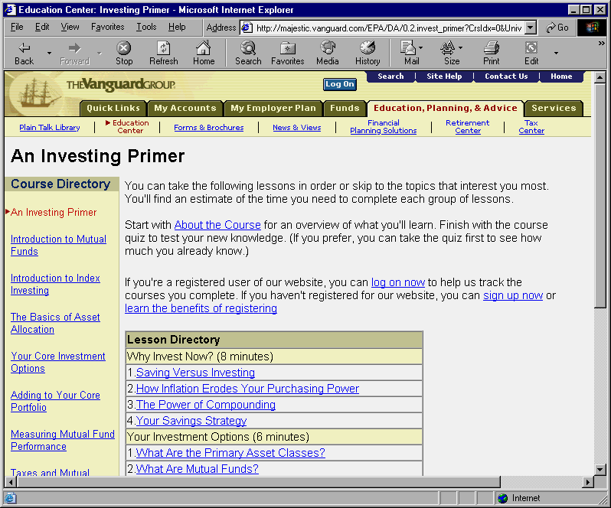 | B2C | Obtained information about investing in the stock market, mutual funds markets, and markets for other instruments.  Search yielded comparative fund information such as returns, expense ratios, ratings, market capitalization, family type, price history, etc.  Obtained list of best-rated funds according to search criteria. | Was able to determine the best investment strategy to fit my risk tolerance.  Obtained all critical information appropriate to my investment needs.  Enabled me to manage all of my investments online.
Fidelity.com  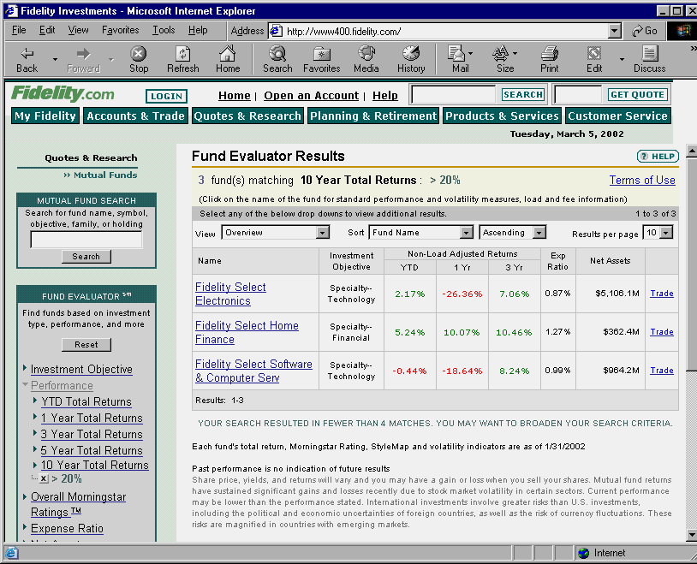 | B2C
Morningstar.com  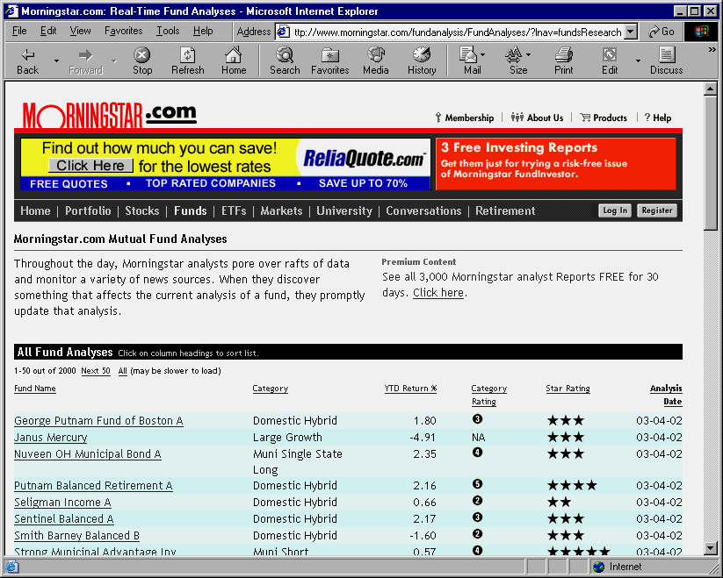 | B2C

